Smart University Research Collaboration and Innovation Management Platform

Field | Details
Submitted By | S. Harsha Vardhan Reddy
Register No. | 192372215
Department | CSE(AI)
Subject | Software Engineering
Faculty | Dr. Latha R.
College | SIMATS Engineering
Academic Year | 2023 – 2027

Table of Contents
1. Introduction and Problem Context
2. System Requirements Analysis
3. Selected Software Architecture
4. Software Architecture Diagram
5. Components and Their Interactions
6. System Workflow
7. Quality Attribute Analysis
8. Justification of Architectural Decisions
9. Trade-offs Considered
10. Future Enhancements and Long-Term Maintainability
11. Conclusion

1. Introduction and Problem Context
This report presents an Architecture Design Analysis for the Smart University Research Collaboration and Innovation Management Platform, prepared in response to the assigned individual software project problem statement. The report follows established software engineering principles to analyze system requirements, select and justify an appropriate architectural style, present a detailed architecture diagram, explain component interactions, evaluate quality attributes, and justify the architectural decisions made.

1.1 Problem Statement
Universities conduct multidisciplinary research involving faculty, students, industries, and funding agencies. Managing research projects, publications, patents, and collaborations requires integrated digital platforms to improve research productivity and innovation. Research management in universities is often fragmented across multiple departments, making it difficult to track projects, funding opportunities, publications, and intellectual property.
An intelligent research management platform is therefore required to automate project monitoring, identify collaboration opportunities using AI, manage research outputs, recommend funding schemes, and generate institutional research performance analytics.

1.2 System Objectives
- Manage research projects digitally through a centralized workspace covering the full project lifecycle.
- Track publications and patents in a structured, searchable repository linked to researchers and projects.
- Identify collaboration opportunities across departments using AI-driven semantic matching.
- Recommend funding opportunities to eligible researchers and project teams.
- Monitor project milestones with predictive risk indicators.
- Generate research analytics and institutional performance dashboards.
- Improve knowledge sharing through a unified, searchable research knowledge base.
- Enhance overall research productivity by reducing administrative and reporting overhead.

2. System Requirements Analysis
The problem statement was analyzed to distinguish functional capabilities the system must provide from the non-functional constraints that shape the underlying architecture. This separation is critical because architectural style selection is driven primarily by non-functional requirements and quality attributes rather than by functionality alone.

2.1 Functional Requirements
- Create, update, and track research projects through defined lifecycle stages (proposed, active, on hold, completed).
- Record and search publications and patents, linked to their originating projects and authors.
- Automatically suggest potential research collaborators based on interest and expertise similarity.
- Match researchers to relevant internal and external funding schemes and track application deadlines.
- Track project milestones, deliverables, and generate alerts for at-risk deadlines.
- Generate configurable analytics dashboards and exportable institutional performance reports.
- Provide role-based access for faculty, students, industry partners, and administrators.
- Support integration with external bibliographic databases, funding portals, and identity providers.

2.2 Non-Functional Requirements
Quality Attribute | Requirement Description | Architectural Implication
Scalability | Must support growth from a single department to institution-wide, multi-campus usage with increasing concurrent users. | Favors independently scalable services over a single monolithic unit.
Maintainability | Individual modules (e.g., funding recommendation, analytics) must be updatable without redeploying the entire system. | Favors loosely coupled, independently deployable components.
Reliability | Core functions (project tracking, milestone alerts) must remain available even if an auxiliary AI service fails. | Requires fault isolation between services.
Availability | The platform must be accessible to faculty and administrators during business-critical reporting periods. | Requires redundancy and load-balanced access points.
Performance | Search, dashboards, and AI recommendations must respond within acceptable interactive latency. | Requires asynchronous processing for compute-heavy AI tasks and a dedicated search index.
Security | Sensitive data (IP disclosures, budgets, personal researcher data) must be protected with authentication and access control. | Requires centralized authentication and role-based access enforcement at the entry point.
Interoperability | Must integrate with existing bibliographic databases, funding portals, and institutional ERP/HR/SSO systems. | Requires a dedicated integration layer with adapter services.

Taken together, these non-functional requirements indicate that the system must support independent scaling and deployment of functionally distinct modules, isolate failures between modules, and support both real-time request/response interactions and asynchronous background processing — characteristics that strongly influence the architectural style selected in Section 3.

3. Selected Software Architecture

3.1 Selected Style
A Hybrid Architecture combining Layered Architecture, Microservices Architecture, and Event-Driven Architecture is selected for the Platform. The system is organized into six horizontal layers — Client, API Gateway, Application/Microservices, AI & Intelligence, Data, and Integration — while the Application layer itself is decomposed into independently deployable microservices that communicate synchronously through the API Gateway and asynchronously through a central event bus.

3.2 Justification for Selection
- Modular functional scope: the platform's eight objectives (project management, publication tracking, collaboration matching, funding recommendation, milestone monitoring, analytics, knowledge sharing) map naturally onto independently deployable services with distinct release cycles.
- Independent scalability: AI-driven services such as collaboration matching and funding recommendation are computationally heavier and need to scale independently of lighter-weight services like project management.
- Fault isolation: a microservices approach ensures that failure or slow response in one service (e.g., the AI recommendation engine) does not bring down core operational functions such as project or milestone tracking.
- Asynchronous processing needs: several workflows (metadata extraction from new publications, milestone risk scoring, funding deadline notifications) are naturally event-driven and do not require an immediate synchronous response, justifying the addition of an event bus.
- Layered organization for clarity: wrapping the microservices in an overall layered structure (client, gateway, application, data, integration) keeps the system understandable and enforces clear separation of concerns between presentation, business logic, and persistence.

3.3 Why Alternative Styles Were Not Selected
Alternative Style | Reason Not Selected as Primary Style
Pure Layered Architecture | Does not allow independent scaling or deployment of individual functional modules; a single scaling bottleneck in one layer affects the whole system.
Pure Client-Server | Too simplistic for a system with many distinct business capabilities and heterogeneous scaling and processing needs.
Pure MVC | MVC is a presentation-layer pattern and does not address backend scalability, service decomposition, or integration concerns at institutional scale.
Pure Service-Oriented Architecture (SOA) | Heavier, centrally-governed ESB-style integration is more complex than needed; microservices with a lightweight event bus offer comparable decoupling with less overhead.
Serverless (pure FaaS) | Long-running AI model inference and stateful project workflows are less suited to strict serverless function timeouts; used only selectively, not as the primary style.

The hybrid approach retains the clarity of layered thinking while gaining the scalability, fault isolation, and independent deployability of microservices, and the responsiveness benefits of event-driven communication for background and cross-cutting workflows.

4. Software Architecture Diagram
The diagram below illustrates the complete structure of the proposed system, including all major layers, microservices, the AI/Intelligence layer, the event bus, data stores, and external integrations, along with the communication mechanisms (synchronous REST/GraphQL calls, asynchronous events, and AI advisory data exchange) used between them.
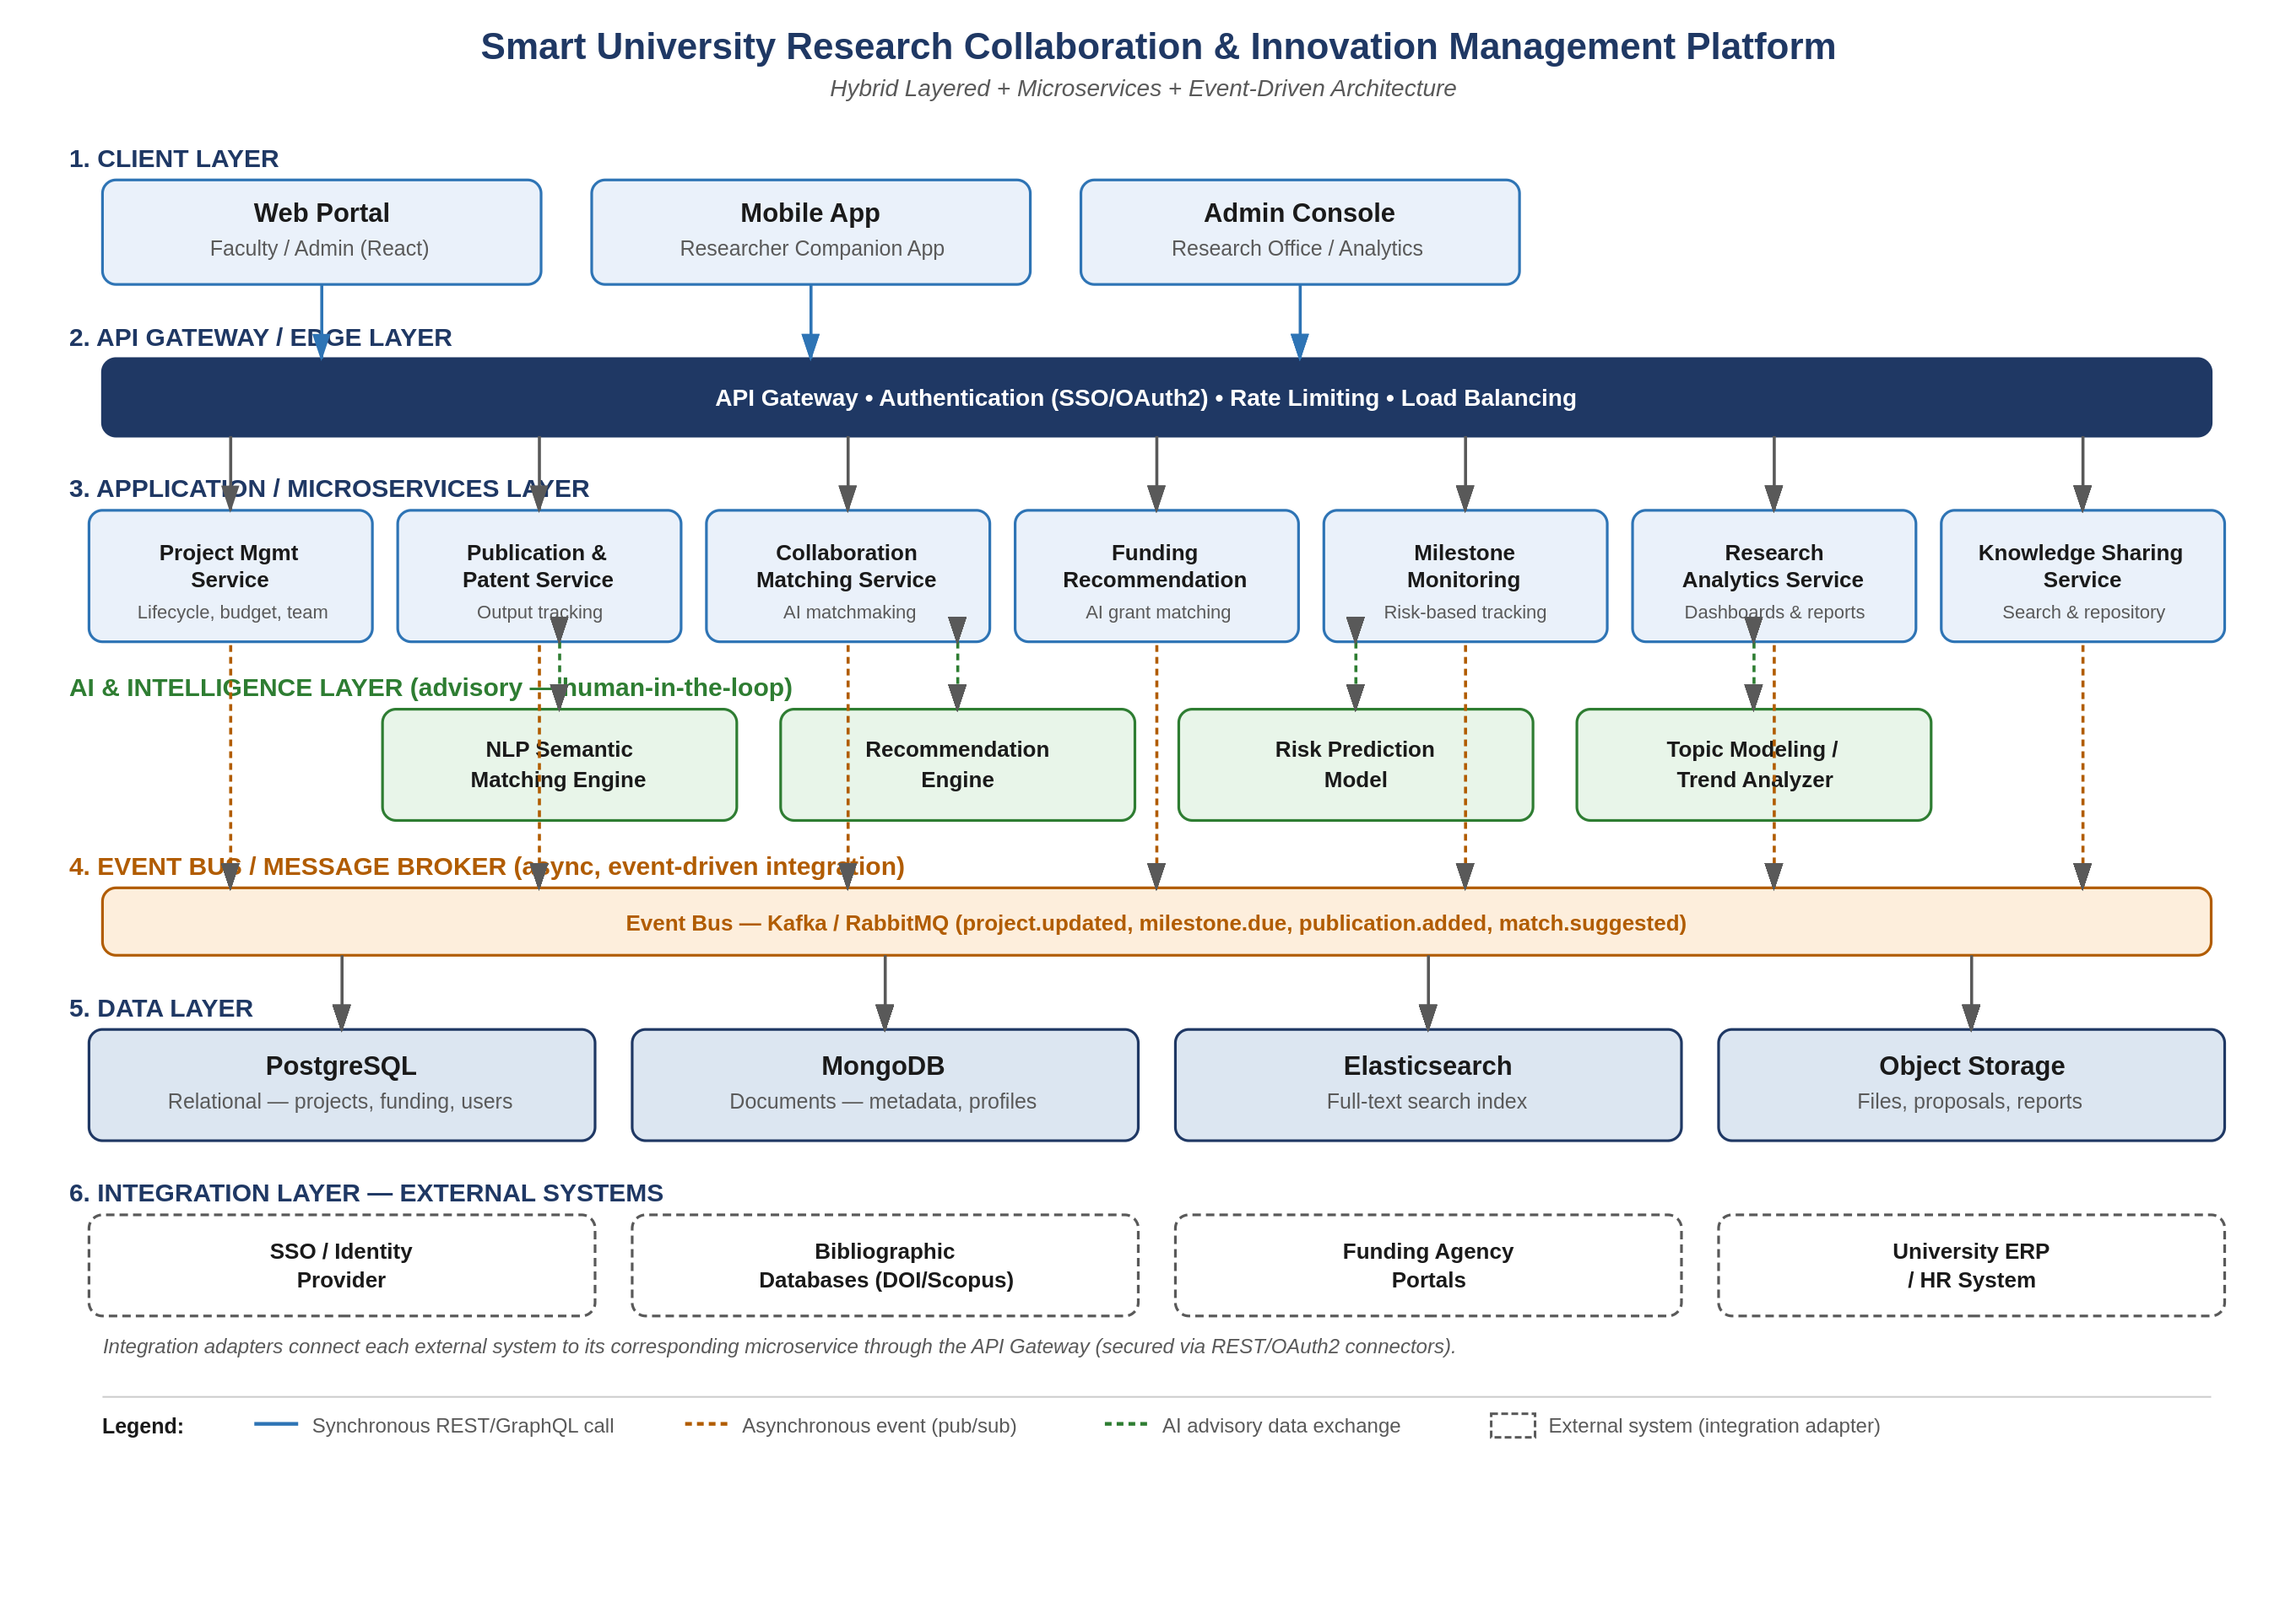
Figure 1: Hybrid Layered + Microservices + Event-Driven Architecture of the Smart University Research Collaboration and Innovation Management Platform

5. Components and Their Interactions

5.1 Client Layer
The Web Portal, Mobile App, and Admin Console provide role-based user interfaces for faculty, researchers, students, industry partners, and research administrators. These clients contain no business logic; they consume data exclusively through the API Gateway using REST/GraphQL calls over HTTPS.

5.2 API Gateway / Edge Layer
The API Gateway is the single entry point for all client requests. It is responsible for authenticating users via Single Sign-On (SSO) and OAuth2, enforcing rate limits, routing requests to the appropriate backend microservice, and load-balancing traffic across service instances. Centralizing these cross-cutting concerns at the gateway avoids duplicating security logic across every service.

5.3 Application / Microservices Layer
- Project Management Service — manages project lifecycle, team assignment, and budget tracking.
- Publication & Patent Service — ingests, stores, and links research outputs to projects and authors.
- Collaboration Matching Service — computes and serves AI-driven collaborator suggestions.
- Funding Recommendation Service — matches researchers to relevant grant and funding schemes.
- Milestone Monitoring Service — tracks deliverables and triggers risk-based escalation alerts.
- Research Analytics Service — aggregates data across services to produce dashboards and reports.
- Knowledge Sharing Service — provides unified full-text search over projects, publications, and profiles.
Each microservice owns its own data and exposes a well-defined API, allowing teams to develop, test, deploy, and scale each service independently without affecting the others.

5.4 AI & Intelligence Layer
The AI layer hosts the NLP Semantic Matching Engine, Recommendation Engine, Risk Prediction Model, and Topic Modeling / Trend Analyzer. These components are invoked by the Collaboration Matching, Funding Recommendation, Milestone Monitoring, and Analytics services respectively, and return advisory outputs (ranked suggestions, risk scores) that are surfaced to human decision-makers rather than acting autonomously.

5.5 Event Bus / Message Broker
Microservices publish domain events (e.g., project.updated, milestone.due, publication.added, match.suggested) to a central event bus implemented using Kafka or RabbitMQ. Interested services subscribe to relevant events, enabling asynchronous, decoupled communication for workflows such as notification delivery, analytics aggregation, and AI-triggered re-scoring, without services needing direct knowledge of one another.

5.6 Data Layer
PostgreSQL stores structured relational data such as projects, funding records, and user accounts. MongoDB stores semi-structured metadata such as researcher profiles and extracted publication metadata. Elasticsearch provides fast full-text search across research artifacts. Object storage holds unstructured files such as proposal documents and reports. Each microservice accesses only the data store(s) relevant to its domain, following the database-per-service principle where practical.

5.7 Integration Layer
Adapter components connect the Platform to external systems: the SSO/Identity Provider for authentication, bibliographic databases (e.g., DOI/Scopus-style services) for publication metadata, funding agency portals for grant call ingestion, and the university ERP/HR system for staff and student records. All integration traffic is routed and secured through the API Gateway.

6. System Workflow
The following end-to-end example illustrates how the architectural components interact for a representative use case: a faculty member creates a project and receives an AI-generated collaboration suggestion.
- The faculty member logs in through the Web Portal; the API Gateway authenticates the request via the SSO/Identity Provider and issues a session token.
- The faculty member submits a new project through the Web Portal; the request is routed by the API Gateway to the Project Management Service, which persists the record in PostgreSQL.
- The Project Management Service publishes a project.created event to the Event Bus.
- The Collaboration Matching Service, subscribed to project.created events, invokes the NLP Semantic Matching Engine in the AI & Intelligence Layer to compare the new project's description against existing researcher profiles.
- The AI engine returns a ranked list of potential collaborators, which the Collaboration Matching Service stores and makes available via its API.
- The Research Analytics Service, also subscribed to relevant events, updates institutional dashboards to reflect the new project in near real time.
- The faculty member is notified of suggested collaborators the next time they access the Web Portal or Mobile App, and may choose to invite them to the project.
This workflow demonstrates the combination of synchronous interaction (login, project creation) with asynchronous, event-driven processing (collaboration matching, analytics updates), which together satisfy both the responsiveness and scalability requirements identified in Section 2.

7. Quality Attribute Analysis

7.1 Scalability
Because each microservice is independently deployable, services under heavier computational load — such as the Collaboration Matching and Funding Recommendation services, which invoke AI models — can be scaled horizontally by adding more instances, without needing to scale lower-load services such as Project Management. The Event Bus further decouples producers from consumers, allowing consumer services to scale independently to handle event backlogs during peak periods such as grant application deadlines.

7.2 Security
Authentication and authorization are centralized at the API Gateway using SSO/OAuth2, avoiding duplicated and potentially inconsistent security logic across services. Role-based access control restricts sensitive operations (e.g., budget edits, IP disclosures) to authorized roles. All external integrations are routed through secured adapters rather than allowing direct external access to internal services or data stores.

7.3 Performance
Compute-intensive AI operations (semantic matching, risk prediction) are handled asynchronously through the Event Bus rather than blocking user-facing requests, keeping interactive response times low. The dedicated Elasticsearch index ensures fast full-text search performance independent of the transactional database workload on PostgreSQL.

7.4 Reliability
Service isolation means that a fault or slowdown in a non-critical service, such as the Topic Modeling / Trend Analyzer, does not directly impact core operational services like Project Management or Milestone Monitoring. Event-driven communication with message persistence in the broker also allows failed consumers to reprocess events after recovery rather than losing data.

7.5 Maintainability
Each microservice has a narrow, well-defined responsibility and owns its own data schema, allowing developers to modify, test, and redeploy one service (for example, upgrading the AI recommendation model) without requiring changes to unrelated services. This significantly reduces regression risk compared to a monolithic codebase.

7.6 Availability
Load balancing at the API Gateway and horizontally scaled service instances allow the platform to tolerate individual instance failures without a full outage. Critical services can be deployed with redundancy across multiple nodes, and the decoupled architecture ensures that maintenance on one service does not require taking the entire platform offline.

8. Justification of Architectural Decisions
The core architectural decision — combining layered organization, microservices decomposition, and event-driven communication — was driven directly by the non-functional requirements identified in Section 2. Institutions require a system that can grow from departmental to institution-wide scale (scalability), continue operating even when individual AI or analytics components are degraded (reliability, availability), be extended with new modules over time without full system redeployment (maintainability), and safely integrate with a range of external institutional and third-party systems (interoperability, security).
A single layered or client-server architecture without service decomposition would have been simpler to build initially but would not meet the independent scalability and fault isolation requirements, since all functionality would share a single deployment and failure domain. Conversely, adopting microservices alone, without an organizing layered view, risks architectural sprawl and unclear separation between presentation, business logic, and data concerns. The chosen hybrid approach retains the conceptual clarity of layers while gaining the operational benefits of microservices and event-driven integration.

9. Trade-offs Considered
Trade-off | Decision Made | Rationale
Simplicity vs. Scalability | Chose microservices over a simpler monolith | Institutional scale and independent AI workloads outweigh the added operational complexity.
Consistency vs. Availability | Adopted eventual consistency for analytics and matching data via the Event Bus | Near real-time analytics is acceptable; strict immediate consistency is not required for these read-heavy, advisory features.
Development Speed vs. Long-Term Flexibility | Invested in a decoupled, layered microservices design over a faster-to-build monolith | The multi-year institutional lifespan of the platform justifies the additional upfront design investment.
Operational Overhead vs. Fault Isolation | Accepted the overhead of managing multiple deployable services and a message broker | Fault isolation between core and AI-driven services is essential to avoid AI component issues affecting core operations.

10. Future Enhancements and Long-Term Maintainability
The selected architecture directly supports future growth in several ways. New functional capabilities — for example, a peer-review coordination module or an international collaboration marketplace — can be added as new microservices that subscribe to existing events on the Event Bus without modifying existing services. Additional AI models can be introduced into the AI & Intelligence Layer and connected to the relevant microservice via the same advisory-call pattern already used for collaboration matching and funding recommendation.
The API Gateway provides a stable integration point for future institutional systems (for example, a new library management system or a national research repository), since new integration adapters can be added at the Integration Layer without requiring changes to the client applications. Because each service is independently deployable, the platform can also adopt new technologies incrementally — for instance, replacing or upgrading the search engine or a specific AI model — without a full-system rewrite, supporting long-term maintainability across the institution's multi-year technology roadmap.

11. Conclusion
This report analyzed the system requirements of the Smart University Research Collaboration and Innovation Management Platform, selected a Hybrid Layered, Microservices, and Event-Driven Architecture as the most suitable architectural style, and justified this selection against the platform's functional scope and non-functional requirements. The architecture diagram and component analysis demonstrate how the system satisfies scalability, security, performance, reliability, maintainability, and availability requirements, while the trade-off and future-enhancement discussion shows that the design is well positioned to support the institution's research management needs over the long term.

